VERMONT ELECTRIC COOPERATIVE, INC.
REGULAR MEETING OF THE BOARD OF DIRECTORS

APPROVED MINUTES

April 25, 2023

As required under the VEC Bylaws, notice of this meeting was sent to each director on April 17, 2023, either via US Mail or by electronic means for those directors requesting such delivery.

Board Members Present: | Rich Goggin (President), Paul Lambert (First Vice President), Carol Maroni (Second Vice President), John Ward, Tom Bailey, Ken Hoeppner, George Lague, Bonnie Pratt, Mark Woodward, and Don Worth.
Staff Present: | Rebecca Towne (CEO), Caroline Mashia (Chief Financial Officer), Andrea Cohen (Manager of Government Affairs and Member Relations), John Varney (Manager of Safety, Security, and Facilities), Laura Kinney (Project Planner), Vickie Brown (General Counsel), Jeff Bickford (People and Culture Leader) and Cyril Brunner (Innovation and Technology Leader).  Brian Hall (Engineering Manager), Jake Brown (Energy Service Planner) and Sara Packer (Vegetation & Right-Of-Way Manager) attended part of the meeting.

AGENDA ITEM #1 -- CALL TO ORDER
Since President Goggin was attending remotely, First Vice President Lambert presided. Lambert called the meeting to order at 12:00 noon. Brunner introduced Brian Hall, VEC’s new Manager of Engineering.

AGENDA ITEM #2 -- SAFETY MINUTE
Ward reminded everyone of the importance of using sunscreen when outdoors in the summer.

AGENDA ITEM #3 -- APPROVE BOARD MEETING MINUTES
Hoeppner moved and Lague seconded that the minutes of the regular monthly Board of Directors meeting held March 28, 2023, be approved as presented. There were three clarifications requested: (1) to add a statement in summary of the discussion of the auditors’ report that VEC has a policy requiring competitive bids for the auditor function every five years, (2) to clarify that members who have questions about broadband providers in their area may be directed to Rossi, and (3) to clarify that costs to purchase and install line extensions are borne by members even though the equipment is owned by VEC.

The minutes, as amended, were approved by unanimous vote.

AGENDA ITEM #4 – REVIEW FORM 990
Mashia noted that the 990 form, provided in advance to the directors, was prepared as it has been in the past and no changes in law would affect this year’s form. It was prepared jointly by staff and Kittell, Branagan and Sargent, VEC’s accounting firm.

Bailey moved and Ward seconded that the VEC Board approve the presented 2022 IRS Form 990 tax report for VEC, subject to any final changes recommended from VEC’s auditors.

A director asked about the need for accuracy in reporting hours worked by directors, since it is very hard to estimate. Mashia responded that a best estimate is sufficient for the 990 form. A director asked for clarification as to the types of changes that the auditors may make. Mashia responded that while she did not expect any material changes, she would convey anything of importance to the Board.

There were a few additional questions from the Board about the details in the form.

The motion passed by unanimous vote.

AGENDA ITEM #5 – ANNUAL MEMBER SURVEY TOPICS
Cohen reported on the development of the 2023 annual member survey. She noted that VEC plans to continue to have NRECA administer the survey as it has in the past, given their expertise in survey design. It is important the survey is not too long and that questions remain fairly consistent from year to year to highlight trends.

The survey will launch at the end of May and extend through June, with the goal of 1000 members responding from across the service territory.

She explained the changes suggested for the 2023 survey, including
- Adding a question about how members are affected when electricity is off.
- Adding a question about members’ expectations as to estimated restoration times.
- Changing the questions about accuracy of metering and billing to be more open ended to understand the real concerns of members.
- Adding an inquiry about members’ preferences for office hours.
- Inquiring as to why some members want to continue to receive paper bills as opposed to e-bills.
- Adding a question about how members heat their homes and how likely members would use electricity for home heating in the future.
- Refining the questions about power resources to better learn about members’ preferences for electricity sources.

There were numerous questions, feedback, and suggested changes from directors throughout the presentation. Cohen will take these into consideration when working with the NRECA to fine-tune the final survey questions.

A director noted that this discussion had previously been held in the Communications Committee and advocated that in the future, the Board return to that process.

Maroni moved and Worth seconded that all future annual surveys be reviewed by the Communications Committee prior to coming to the Board. There was discussion as to whether this could be resolved in separate conversations as the Board plans its future work.

The question was called, and the motion passed on a five to two vote with one abstention.

AGENDA ITEM # -- BEAT THE PEAK PROGRAM UPDATE
Brunner noted that VEC has contracted with Qilo to measure the value of VEC’s Beat the Peak Program. They analyzed AMI data for residential members to compare usage during beat-the-peak periods to baseline usage from 2018-2022. They grouped the members into categories based on their engagement levels in limiting usage during peak periods. The key findings were:
- Even though at present the savings to VEC are small, the Beat-the-Peak Program is working to influence member behavior to limit peak usage -- with very low cost to VEC.
- VEC should target early adopters of other programs (time-of-use rates, Packetized program, and hot water heater program) to leverage Beat-the-Peak participation.
- Not all members are appropriate for the Beat-the-Peak program, as some groups did not respond to peak notifications or actually increased their usage during peak periods.
- VEC should add touch points to increase engagement of medium- to low-engaged members who have enrolled in the program.

There was a suggestion that VEC consider an approach by BED where they set targets for peak usage reductions, which if met would result in a donation to a local non-profit.

Brunner further explained VEC’s current outreach to expand participation in this program, including by use of press releases, website posts, emails and texts, and several social media platforms.

There were numerous questions and comments from various directors throughout the presentation.

AGENDA ITEM #7 – BREAK

There was a break from 1:53-2:08.

AGENDA ITEM #8 –VEGETATION MANAGEMENT UPDATES
Sara Packer, VEC’s Vegetation & Right-Of-Way Manager joined the meeting.

Packer provided an overview of VEC’s vegetation management program. She shared the stories driving the key statistics about VEC’s progress in 2022, as follows:

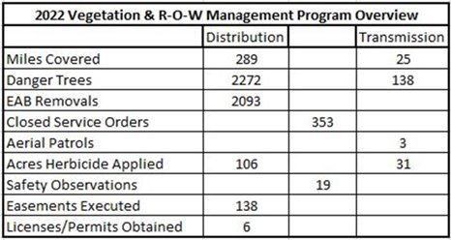

A director asked for more information about the herbicides that VEC uses. Packer noted that all herbicide applications are covered by permitting through the Department of Agriculture.

She also summarized other accomplishments of the Vegetation Management and Right of Way team during 2022, i.e.:
- Expanded Department​ to include new forester and moved the Right of Way Associate to this team
- Renewed focus on regulatory procedure and environmental guidance​
- Shortened distribution vegetation maintenance cycle​
- Provided support for capital projects​
- Extensive member/community interaction​
- Continued emerald ash borer (EAB) mitigation​
- Contractor Management ​-- all vegetation activities are implemented by contractors
- Safety trainings​
- Storm response

The results of this work have been to decrease the duration and quantity of tree-related outages as shown in the following chart.

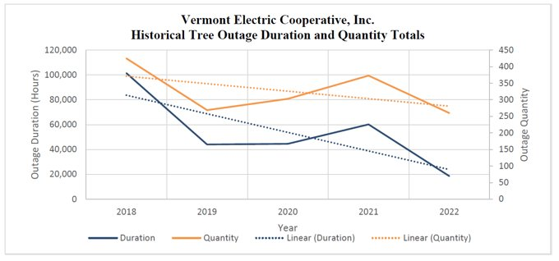
Some new focuses for 2023 include:
- New vegetation management software​
- Expanding use of mechanized or specialized equipment​
- Work on environmental guidance manual​
- Exploring new technology​
- Re-adjusting EAB approach​

There were questions from the directors throughout her presentation. The directors also complimented Packer on the work of her vegetation management team.

AGENDA ITEM #9 AMI NEXT GENERATION
Brunner provided a history of VEC’s initiatives to move to automated meter reading (AMI) beginning in 2001, leveraging grant funding as an early adopter, which resulted in significant savings in meter reading costs and system losses. As part of this process, VEC realized that its AMI system collected valuable member usage data, and VEC developed its “WattWatchers” program to allow members to monitor their usage. This program was adopted by NRECA as the basis for the SmartHub application, and NRECA recognized VEC’s contribution to this customer-focused application, which many co-ops use today.

He noted that currently members interact with the AMI system through the SmartHub application to understand their usage and monitor outages on VEC’s system. VEC uses AMI data to assess transformer loading and identify where upgrades may be needed.

The first iteration of AMI relied on “power line carrier” (PLC) technology, which means the data flows over the electric lines to VEC’s meter database management (MDM) system. The next generation of AMI will rely on radio frequency, which sends data over radio signals to connect to the MDM system.

He noted that the PLC system poses a number of challenges, prompting the need for an upgrade. These challenges include:
- Frequent support and troubleshooting are required by qualified personnel in substation, metering and IT groups.
- There is limited ability to react to system changes, such as block load switching.
- There have been false reports of outages, requiring unnecessary site visits.
- Tech support for the current system has been challenging with long response times.
- PLC has limited functionality and is limited by bandwidth.

He noted that in the future with the addition of new electric load and new generation, high quality metering will be key to achieving VEC’s strategic goals as it will allow for near real-time data visibility into system usage.

Other benefits of upgrading VEC’s AMI system include:
- Ability to provide pro-active outage response.
- More insights for members on their usage and help with understanding high bills.
- Ability to automate communications among distribution devices such as reclosers and regulators.
- Opportunity for remote disconnection of non-critical loads in emergencies.
- Ability to better orchestrate grid usage, e.g. managing EV charging to avoid overloading transformers and lines.

Finally, he outlined the timing of this initiative, which will begin in 2023 with vendor selection (though an RFP process) and be implemented over the following four years.

AGENDA ITEM #10 – MANAGERS REPORST
Towne noted that Kinney will follow up with additional detail as to several upcoming offsite meetings and conferences.

Several directors stated that they were pleased to see that VEC’s credit rating has been maintained at A+ positive.
There was a lengthy discussion about decisions that ISO-New England has made to ensure that power will be available during the winters of 2022 and 2023, which has proved to be expensive and somewhat unpredictable, but ultimately a necessary insurance policy against really cold winters. Towne noted that VEC is working through VELCO on getting more transparency into these charges from ISO-New England.

Mashia noted that the Public Utility Commission approved VEC’s rate increase.

There were additional questions about details in other managers’ reports.

AGENDA ITEM #11 -- OTHER BUSINESS
There was no other business.

AGENDA ITEM #12 – ADJOURN
Woodward moved and Bailey seconded to adjourn. By unanimous vote, the meeting adjourned at 3:57 p.m.
Respectfully submitted:

Mark Woodward, Acting Secretary |  | Rich Goggin, President

