June 2022 – Communications

Highlights

* Included a short survey in the most recent C&I email newsletter. Key question results included these:

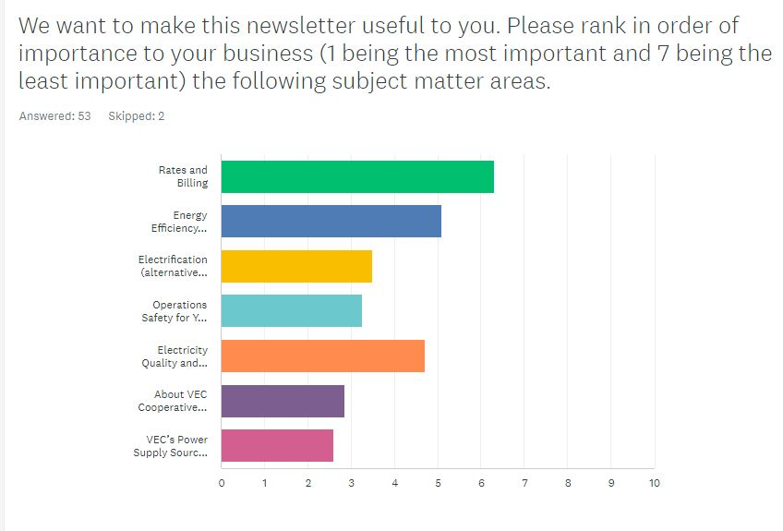

In addition, this: 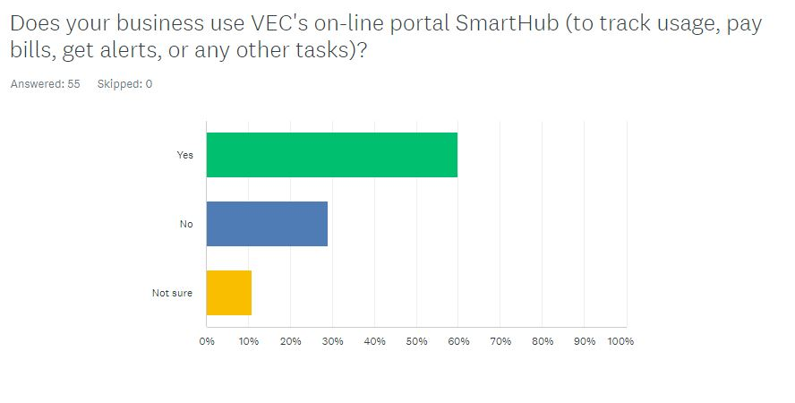*Neither of these results was surprising. The first will guide our topic selection and the second reminds us of the continued opportunity to promote SmartHub.*

* Now leading with the “VEC brand anthem” video in our “new member” emails. That video, shown at the 2022 Annual Meeting, is a great way to offer a short, compelling overview of the Co-op and set a foundation for member identity with new members.)

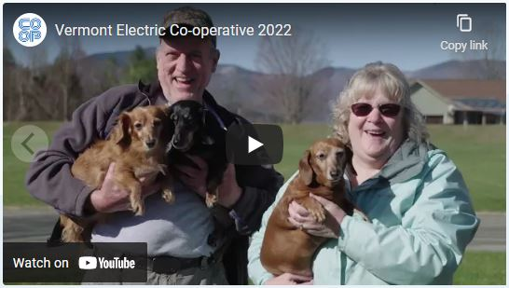

Other items

* Created Part 1 of SmartHub use video series with “How to Sign Up for SmartHub” with MSR Monica Stearns. View at: <https://youtu.be/H3jF0nWTwl8>. (In Part 2 Monica will highlight some key features of SmartHub).



* Supported our LGBTQ+ members, employees, friends and neighbors in social media post for Pride Month.
* Other social media included COVID arrearage assistance, peak demand/Beat the Peak, and Community Fund.
* Unusual winning technology in June ChargeItUp drawing: electric Christmas tree shearer.

**Dashboard:**

* New Social Media Followers: 35
* Total Social Media Followers: 5230
* Press hits: 6

Press hits year to date: 48